PHASE IV: PROJECT DESIGN
Date | 06 November 2025
Team ID | NM2025TMID08793
Project Name | Lease Management
Maximum Marks | 4 Marks

Title: Project Design Phase for “Lease Management”

- Objective
The objective of the Design Phase is to convert the defined requirements into a complete system architecture for the Lease Management application.
This phase creates the user interface layout, process automation logic, data security controls, and reporting dashboards that support digital lease lifecycle management.
Key design focus areas:
  - User Interface (Property, Tenant, Lease, Payment pages)
  - Automation Flows & Validation Triggers
  - Security & Role-Based Access
  - Real-Time Reporting and Dashboards

- Design Overview
The Lease Management app leverages Salesforce Lightning features to build a structured, automated lease management system.
  - The application design is Centered around:
  - Five core custom objects (Property, Tenant, Lease Agreement, Payment,
  - Maintenance Request) Automated flows for lease creation and rent scheduling
  - Apex trigger to auto-calculate rent due status
  - Dynamic dashboard tracking occupancy, rent, and maintenance
  - Role-based visibility for tenants, managers & admins

- User Interface (UI) Design
3.1 Lightning App Design
A custom Lightning App named “Lease Management” was created for property managers and tenants.
Steps followed:
1. Setup → App Manager → New Lightning App 2. Added branding logo, app name, and description
3. Navigation tabs included:
    - Home
    - Properties o Tenants o Lease Agreements o Payments o Maintenance Requests o Reports & Dashboards
Design Principles Applied:
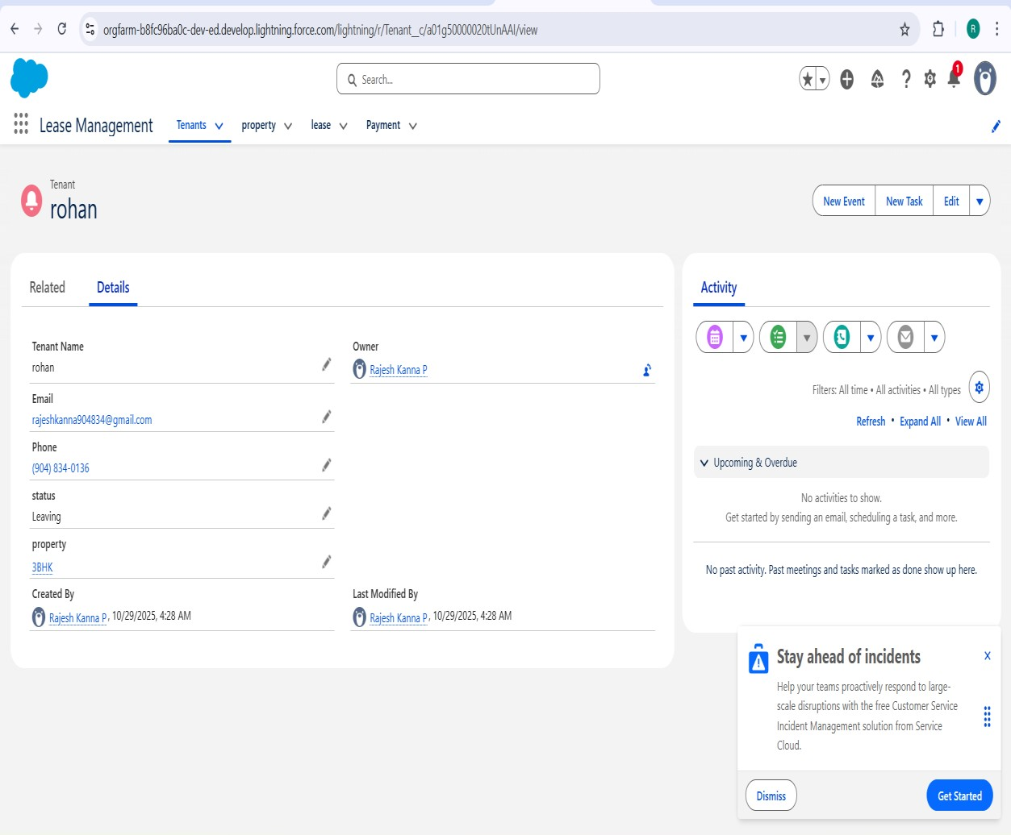

Principle | Purpose
Role-Based UI | Tenants see only leased properties & payments
Clean Layout | Wider spacing, reduced form clutter
Guided Navigation | Buttons and flows for quick lease registration

3.2 Home Page Design
Component | Purpose
Quick Action Flow | “Create Lease Record” flow for faster onboarding
Dashboard View | Shows active leases, overdue payments, vacant properties
Announcement Panel | Displays renewal alerts and maintenance updates

- Automation Design
Automation reduces manual work by handling rent schedule generation, alerts, and validations.
  - Screen Flow – Lease Creation Flow Flow Steps:
    - Collect Tenant + Property selection
    - Enter Lease Start Date, End Date, Monthly Rent, Deposit
    - Auto-generate Payment Schedule records
    - Confirm with success screen “Lease Created Successfully”
    - Eliminates manual creation of monthly rent entries
    - Improves data accuracy

  - Apex Trigger Design – Auto Payment Status Update
Apex Trigger on Payment object updates payment status before record save:
IF (Due_Date__c < TODAY AND Paid__c = FALSE)
Status__c = "Overdue"
• | Trigger Event | • | Action
• | Before Insert / Update | • | Auto update status based on due date
    - nsures real-time rent status without manual tracking

- Security Design
  - Profile-Based Access
Profile | Access Level
Tenant Profile | Read Own Lease, Create Maintenance Requests
Property Manager Profile | Full CRUD on Lease, Property, Payment
System Admin | Full Access & Setup Controls

  - Sharing Rules
Rule | Shared With | Purpose
Lease.Status = "Active" | Assigned Tenant | View active lease
Payment.Status = "Overdue" | Property Managers | Follow-up rent collection
Maintenance.Urgency = "High" | Property Managers | Escalation workflow

    - Prevents tenants from seeing other tenant data
    - Managers get 360° visibility

- Reporting and Dashboard Design
  - Reports Created
Report Type | Purpose
Lease Agreement with Tenant | Track occupancy rate
Payment with Lease Agreement | Rent collection analysis
Maintenance Requests | Service response monitoring

  - Dashboard Components
Component | Visual Type | Insight
Occupancy Overview | Donut Chart | Active vs vacant properties
Rent Collection Trend | Line Chart | Monthly rent flow
Overdue Payments | Bar Chart | Pending rent by tenant
Lease Expiry Alerts | Table | Contracts ending in next 30 days

- System Architecture Design
Layer | Component | Purpose
Presentation Layer | Lightning Pages, App UI | User interaction
Logic Layer | Flows, Apex Trigger | Automates leasing logic
Data Layer | Custom Objects | Stores lease lifecycle data
Analytics Layer | Reports, Dashboards | Insight for managers

- Design Constraints
Constraint | Impact | Solution
Large number of payment records | Slower report load | Use archived table after 3 years
Frequent rent reminders | May spam tenants | Schedule once per day
Mobile UI layout resizing | Scroll issues | Enable dynamic responsive layouts

- Future Design Considerations
Enhancement | Benefit
SMS/Email rent reminder integration | Reduces missed payments
Mobile App Tenant Portal | Easier lease & payment access
AI rent prediction model | Forecast revenue & renewal trends

- Summary
The Project Design Phase establishes the structural and visual foundation of the Lease Management system.
The combination of Lightning UI, automated Flows, smart triggers, and secure access ensures a scalable, low-maintenance, smart leasing platform.
    - Modern, UI-focused design Fully automated payment tracking
    - Role-based and secure data handling
    - Real-time dashboard for leasing KPIs
This design now enables smooth transition to Phase V – Implementation & Testing.

